Input information part:

* The first step does not forces the user to choose the highway – **Solved with an alert**
* In the responder unit tab, if a certain kind of response unit first arrives, then it should force the number of this kind of unit is equal or more than one. – **Solved with an alert prompting user to enter number of vehicles for selected first responder**
* When the user change input information about “response unit”, the summary (bottom left panel) is not correctly updated. For example, if I set there are 3 police arriving, and then change it to 0 police arriving, the summary does not change – **Added an else statement to catch a NULL case, and to reset the model to null for number of responders**
* Rules for I-695 includes “more than 5 response units”, “more than 6 response units”, “more than 7 response units”, and “more than 8 response units”, but the user can only input up to 5 units. The options for the number of units should 1, 2, 3, 4, 5, 6, 7, 8, 9+. 9+ means “more than 8 response unites”. You may also need to change the code for the ruled related to this change. A detailed example is shown in CPI1(2) in the following part. – **Dropdowns for number of vehicles has been updated**

Below are some cases that are categorized to the wrong duration intervals. Please make sure you understand what error in the code causes each wrong estimation before you revise the code. All these mistakes are associated to CPI 1 but the logic issue may happen under other incident types. Please check carefully.

Logic problem for the model:



**Changed else statement after CPI1-2 to result in CPI-2 instead of CPI-3 which should fix errors CPI1 (1) and CPI1 (3)**



**Selection has been updated. Now users can select many more responder units.**



**Updated with CPI(1).**



**Updated with CPI(1). An issue with the conditionals for CPI-2 allowed it to proceed to CPI-4, which has been fixed.**



A correction of duration estimation: **Corrected**

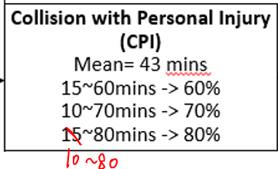

**Yes already included:**

